
The Journal of the British Association for the Study of Religions (www.basr.ac.uk)
ISSN: 0967-8948

Diskus 13 (2012): 1-9
http://www.basr.ac.uk/diskus/diskus13/Rue.pdf

Rite Makes Right

Dr. Loyal Rue
Luther College
rueloyal@luther.edu

ABSTRACT:
This paper considers ritual phenomena in the context of a naturalistic theory of religion. Religious traditions are described as mythic traditions, where myth is understood to be a narrative integration of cosmological and moral ideas. Ritual practices emerge as part of a cluster of strategies that function collectively to revitalize the power of the myth to influence the ways people think, feel and act.

* * *

For more than a century it has been conventional wisdom in some quarters to say that religion is passé, washed up, kaput. Religion is nothing but a prescientific way to explain natural phenomena, or it’s nothing but a dysfunctional way to cope with psychological or social conflicts. And when you think hard about this question it becomes clear that no one really needs a religious tradition in order to achieve a satisfying view of natural phenomena, and no one really needs a religious tradition in order to achieve sanity and solidarity. So why on earth do religious traditions persist?
For some people the problem goes even deeper—not only is religion unnecessary, it is ultimately fallacious, a huge mistake. That was the view taken by the American pragmatist, Richard Rorty. For Rorty, religion is a mistake because it presumes to do what cannot possibly be done: that is, religion (and nearly all of Western philosophy) attempts to capture truth and goodness, ultimate facts and ultimate values, within a unified vision.
As I tried to figure out what had gone wrong [in the Western intellectual tradition], I gradually decided that the whole idea of holding reality and justice in a single vision had been a mistake (Rorty 1999: 12).
Here Rorty is rejecting the possibility of achieving a coherent vocabulary that might integrate truth and value. This is an old story: facts are facts and values are values, and never the twain shall meet.
But Rorty doesn’t stop here. Consider this:
This book tries to show how things look if we drop the demand for a theory which unifies the public and the private, and are content to treat the demands of self-creation and of human solidarity as equally valid, yet forever incommensurable (Rorty 1989: xiv).
Here Rorty rejects the possibility of achieving a coherent vocabulary for bringing personal values into line with social and political ideas. The interests of the individual and the interests of the group—that is, happiness and virtue, therapy and politics—are radically incommensurable.
Now, I want to suggest that religious traditions persist precisely because they presume to give us the two things that Rorty tells us we cannot have. That is, they give us a unified vision of truth and value; a unified vision of how things are and which things matter. And religious traditions also give us a universal vision of the good, which has the potential for creating genuine overlaps of self-interest. Defenders of religion are likely to insist that not only can we achieve these integrative ways of thinking, but we must achieve them, for otherwise we will fail to have a satisfying understanding of either the natural order or human existence.
The topic at hand is “ritual knowledge”, not the nature and persistence of religious traditions. But my argument would be that religious traditions persist because of the kind of knowledge that people construct, partly as a result of ritual performances.
I take the view that there is a systemic relationship between religion and ritual. Ritual is part of the larger phenomenon of religion, and you can’t really apprehend the parts without the whole, or the whole without the parts. But we’ve got to begin somewhere, so for the moment I want to describe religious traditions in a general way, as whole systems within which ritual practices have an important role to play. A general theory of religion will attempt to say something about the structure, the function and the origins of religious traditions.
Here’s the picture I get of the fundamental structure of the religious vision:

Cosmology
(how things are)

MYTH

Morality
(which things matter)

Myth, literally, means story, and all religious traditions have at their core a story that integrates facts and values. A myth brings together cosmological elements about how things are in the real world with moral values about which things matter for human fulfillment. Religious traditions, then, systematically violate the naturalistic fallacy by con-fusing truth and goodness. But consider the suggestion that our brains themselves are naturalistic fallacy violators. That is, every good brain must accomplish three things. First, it must encode relevant information about the world around. Second, it must encode vital information about the internal state of the organism (i.e., the biological value system). And finally, a brain must integrate these independent streams of information in order to devise adaptive behaviors. The point is that religious traditions pull off the same trick at the level of social-symbolic systems.
What actually does the work of integrating facts and values is metaphor. At the core of any religious tradition, therefore, one can expect to find a root metaphor that links cosmological ideas to moral ideas. In the Abrahamic traditions, for example, one finds the root metaphor of God-as-person. God-as-person generates a unified vocabulary for thinking about how things are and which things matter. God is the creator of the universe, and God is also the author of the moral order. God, then, is the ultimate explanation for all facts, as well as the ultimate justification/condemnation for all values. The result is that the religious vision delivers a cosmos infused with value and values that are endowed with the status of objective facts. God-as-person is the most commonly used root metaphor, but it is not the only one. Consider the role of the Logos in Greek tradition; the Tao in Chinese traditions; and the Dharma in Vedic traditions.
Religious traditions are narrative traditions. But they are also historical traditions, which means that they must take measures to maintain themselves. Thus, each religious tradition develops a set of supportive strategies, grouped around the narrative core, working together to keep the story alive in the brains of individuals.

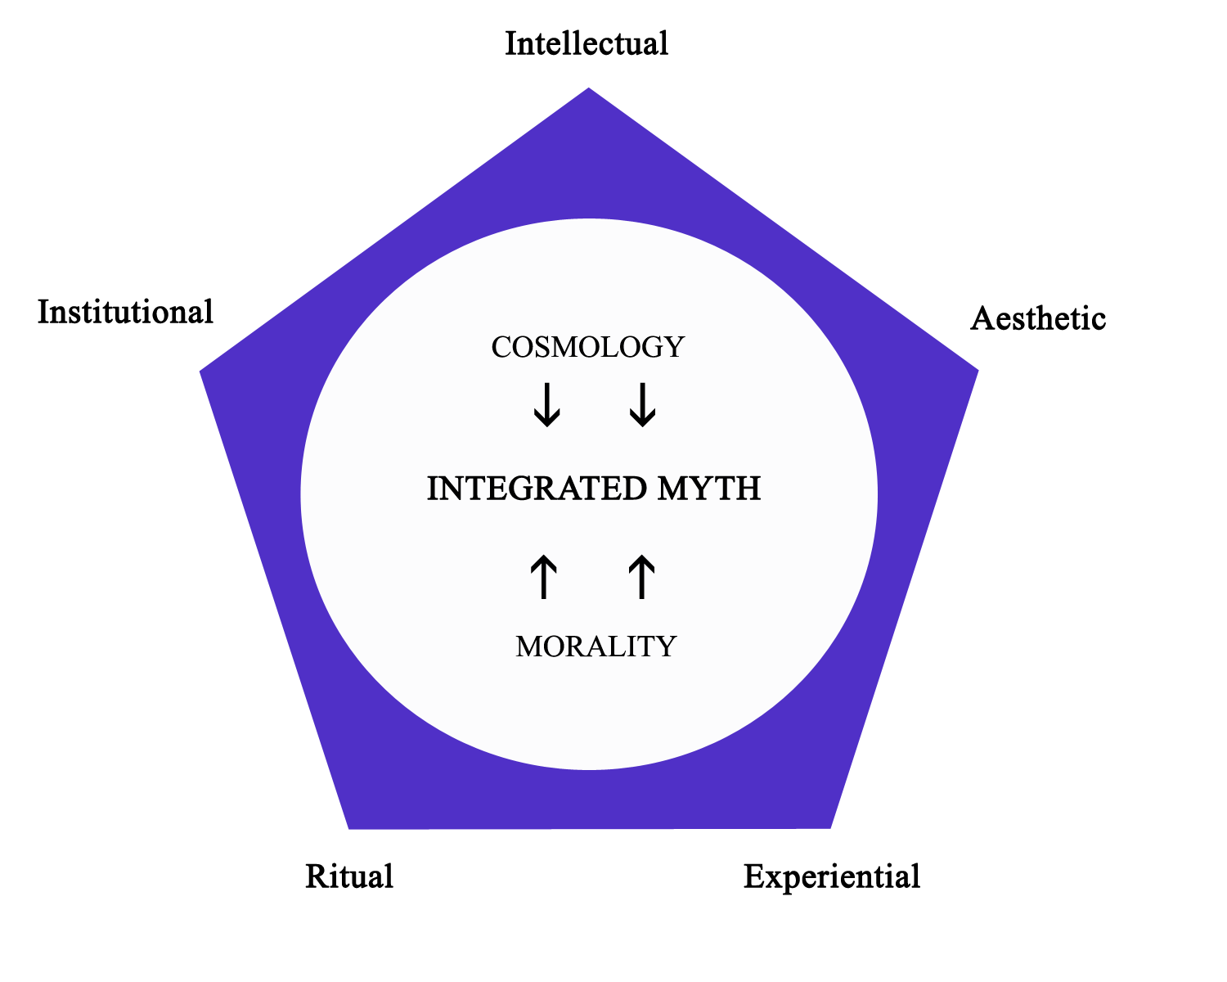
I find myself thinking about this model by analogy to sweeping water into a pile. Theoretically, it should be possible to sweep water into a pile, but the amount of work involved would be enormous. Similarly, it takes a lot of work to advance and maintain the effectiveness of a religious tradition.
Intellectual strategies are designed to maintain the intellectual plausibility and coherence of the central story by clarifying, interpreting and defending it.
Aesthetic strategies are designed to engage emotional systems and memory systems with symbolic imagery, thereby to bias these systems toward behaviors that are consonant with the myth.
Experiential strategies are designed to revitalize the myth by encouraging and enabling extraordinary experiences that function as personal validations of the myth.
Institutional strategies are designed to manage the orderly social transmission of the myth, and to resolve conflicts that arise within the group.
Ritual strategies are designed to revitalize individual and collective commitments to the myth by engaging in periodic social reenactment.
I will have more to say about the ritual strategy later, but first I have a confession to make: I have sold out completely to the paradigm of evolution. I take a paradigm to be an epistemological model that has acquired a commanding influence. That is, a paradigm is the box outside of which an individual or a discipline cannot manage to think. You see this illustrated in Dobszhansky’s claim that nothing in biology makes sense except in the light of evolution. I extend this principle even further, to the claim that nothing in human experience or behavior (including religion) makes sense except in the light of evolution.
If you’re in the evolutionary box as deeply as I am, then you will take the view that teleology (pointfulness, purpose) is a universal and exclusive property of living systems. That is, all living organisms and only living organisms (or their inventions) manifest purposeful behavior. And here the evolutionary paradigm tells us that all living organisms are constituted to behave so that they will achieve reproductive fitness. This is the purpose of all life, the point of all life. At the level of ultimate purpose, therefore, there is no difference between human life and the lives of all other species. The differences lie in the particular strategies used to achieve reproductive fitness. Squids have one set of strategies (or adaptive traits), various bird species have other strategies, and so on. Our question then becomes: What are the peculiar strategies that humans use? We have lots of strategies, of course, but they all boil down to two main objectives: personal wholeness (therapy) and social coherence (politics).
We humans maximize our potential for reproductive fitness by constructing sane and healthy personalities, and by constructing cooperative and harmonious social groups. And herein we find revealed the function of religious traditions: they help us to create the conditions for the simultaneous achievement of personal wholeness and social coherence. That is, they offer us a single, unified vocabulary for conducting therapy and politics. This, I take it, is the wisdom behind the two roles of the Christ figure. The priestly Christ is the therapist, and the prophetic Christ is the political activist. Religious traditions fulfill these roles by the five supportive strategies mentioned earlier.
Now to return to the question of ritual knowledge. I’ve already suggested that ritual practice amounts to one of several overlapping strategies that religious traditions deploy for the sake of maintaining and revitalizing the power of a myth to inform the ways we think, feel and act. Ritual events offer us the opportunity to participate in a reenactment of the ultimate story—and by virtue of this participation individuals are able to map on to the cosmic story. Individuals are able to see the details of their own lives in light of ultimate reality. When this dynamic works properly individuals apprehend the ultimate story of truth and value as their own story. They take ownership of the story, and in this way the details of an individual’s life become intelligible, tolerable and meaningful in the universal scheme of things.
We may see an example of this dynamic in the central rite of Christianity, the mass. The critical point of the myth of Christ’s death and resurrection is one of endurance and affirmation of life. The passion narrative says “this is not the end, there is more life to come.” Everyone can relate to this universal message. We all suffer setbacks, losses, defeats—the slings and arrows of outrageous fortune. And we are always well served by the faith that life is regenerative. Life is often a challenging ordeal—a kind of crucifixion—and we stand ready to respond to the prospect of deliverance from adversity. The language abounds with parallels to the message of the mass:
It’s always darkest just before dawn
Keep the faith
Where there’s life there’s hope
Pick yourself up, dust yourself off, and start all over again
In spite of everything….YES!
What we are given in ritual is a strategy for reconstituting individuals and groups. Ritual gives us a chance to hit the “reset” button, to recalibrate or reconfigure the algorithms of daily life by mapping on to the ultimate algorithms of the cosmos. Rituals rectify. Things are put right again—a rite sets things aright.
So what is known in this process? The view here is that ritual knowledge just is a condensed form of the religious myth itself—so what we come to apprehend in a deep and direct way is what Rorty says we cannot have: that is, a unified vision of ultimate truth and objective value that can inform both our therapy and our politics.
Here’s how it works. Individuals experience happiness and self-fulfillment when they get what they want. The social order becomes cohesive when individuals behave as they should, that is, in socially constructive ways. Religious traditions, at their best, nurture individuals in such ways that they become more likely to want what is collectively defined as good. And herein lies the ultimate formula for a meaningful life: the marriage of happiness and virtue. When we want the good, then we will be made happy by serving the good.
I said earlier that a general theory of religion will say something about the structure, the function and the origins of religious traditions. Religious traditions have a narrative structure that integrates facts and values, ultimate explanations and ultimate justifications. And these traditions function to help us in achieving personal wholeness and social coherence, and thus reproductive fitness. It now remains to say something, briefly and speculatively, about the origins of religion.
Religious traditions originated in what anthropologists have called the great leap forward, occurring about fifty thousand years ago. This event saw a gradual transformation in social organization, from small hunting-gathering bands to somewhat larger tribal alliances. At fifty thousand years ago our ancestors certainly had language at their disposal, and it is very likely that they had developed articulate cosmologies to explain natural phenomena. These primitive cosmologies probably featured spirits and divine agents whose powers might have accounted for various mysteries, such as death, dreams, fertility, and the weather. But moral authority would not have been attributed to these agencies, for the very simple reason that primitive social units already had all the moral rules they needed, right where the genes had put them: in the emotional systems. As social units enlarged, however, there was a need for more complex rules for social regulation. The intuitive morality of untutored emotional systems was not up to the task. When social chaos lurked it fell to social dominants to declare law and order in the form of strange new articulate rules, and then to enforce them with threats of violence. When pressed with demands for justifying what must have seemed like arbitrary and counterintuitive rules, it would have been natural for the rule makers to attribute moral authority to the gods, who were already understood to wield power over natural forces. This attribution marked the origin of religion, for here was the first attempt to integrate cosmology and morality under the persuasive power of a root metaphor. The gods now had the dual role of explaining natural phenomena and justifying moral values. And once there was a basic story in place, the harmony and stability of an enlarged social order came to depend upon revitalizing the myth (read: educating the emotions) by deploying intellectual, aesthetic, ritual, experiential and institutional strategies.

References
Rorty, Richard. 1989. Contingency, Irony, and Solidarity. New York: Cambridge University Press.
Rorty, Richard. 1999. Philosophy and Social Hope. New York: Penguin Books.

